BEGINNING OF TERM ONE EXAMINATION 2024
PRIMARY TWO
READING

Time allowed: 2hour 15 minutes

Name: ______________________________________________________________
School: _____________________________________________________________
FOR EXAMINER’S USE ONLY
Read the following instructions carefully:
- The paper has two sections: A and B
- Section A has 40 questions (40 marks)
FOR EXAMINER’S USE ONLY

Qn. No | MARK | SIGN
1 – 10
11 – 20
21 – 30
31 – 40
41 – 43
44 – 46
47 – 49
50 – 52
53 – 55
TOTAL

- Section B has 15 questions (60 marks)
- Answer ALL questions. All answers to both Sections A
and B must be written in the spaces provided.
- All answers must be written using a blue or black ball
point pen or ink. Diagrams should be drawn in pencil.
- Unnecessary crossing of work may lead to loss of marks.
- Any handwriting that cannot be easily read may lead to
loss of marks.
- Do not fill anything in the boxes indicated; For Examiner’s
use only.

Turn over

1. Write one word with sound oa ______________________
2. A lion is a ___________________animal. (domestic, wild)
3. A room where food is cooked from is called a _____________________. (chicken, kitchen)
4. Plants use their ___________________ to suck water from the soil. (leaves, fruits, roots)
5. A person who flies an aeroplane is called a ____________________ (driver, pilot)
6. We can make _________________ from banana fibres. (pots, saucepans, ropes)
7. Write one use of a mouth.
_______________________________________________________
8. A young of a cow is called a ________________.
(lamb, kid, calf)
9. Why do animals move?
___________________________________________________
10. What uses a railway line when moving? _____________________ (bus, ship, train)

11. Name these means of transport.
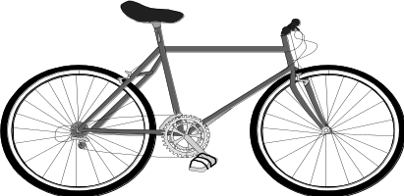

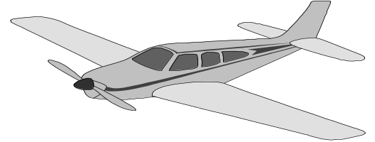

12. Write these sentences correctly.
(a) join I P.2 want to.
___________________________________________________
(b) us A milk gives cow.
___________________________________________________

13. Circle words with ‘tr’ in the sentence.
(a) A triangle has three sides.
(b) There are five eggs on a tray.

14. Fill in the missing letters on these body parts.
(a) ank__e (b) w__ __st

15. Make two sentences from the table.
a uniform  fish | keeps  lives | my body warm  in water.  in our school.

- ________________________________________________
- ________________________________________________

16. Read and draw pictures.
The cow is eating grass. | The weather is windy.

17. Answer correctly.
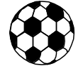
- What are these?
___________________________________________

- Is this a cup?
__________________________________________

18. Read and answer correctly.
(a) You need it to write. It is either blue or black. Teachers use it very much. They like the red one, to mark pupils work.
What is it? ______________________________________

(b) I am always decorated in various colours. I don’t miss parties. Children cut me to celebrate their birthday. I am served to all guests.
What am i? You are ______________________________

19. Underline the tools in a garden.
(a) broom brush panga basin
(b) wheelbarrow, saucepan, desk

20. Write two things we get from a hen.
(a) ___________________________________________________
(b) ___________________________________________________
21. Draw these things we make.
mat | pots | dolls
22. Arrange the sentences to make a good story.
She prepares food in the kitchen.
She buys food and fruits.
She serves the food at the dining table.
Mother goes to the market.
Good story
_______________________________________________________
_______________________________________________________
_______________________________________________________
_______________________________________________________
_______________________________________________________
23. Match the words with similar sounds but different meanings.
feet sun
ship sheep
goat sit
son got
fit
24. Read and write True or False.
(a) A young monkey is called a baby. _________________
(b) A snake moves by hoping. _________________
(c) Good children obey their parents. ______________
25. Read the passage below and answer the questions that follow.
When we are at home, we make things like mats, pots, dolls, baskets, brooms and balls. We make these things from different materials like clay, sisal, banana fibres and bottle tops. We get the materials from swamps, plants, animals and others. We sell the things we make and get money.
Questions:
- What do we make when we are at home?
___________________________________________________
- Where do we get the materials from?
___________________________________________________
- What do we get when we sell the things?
___________________________________________________
26. Read the pictures and answer the questions that follow
One | Two | Three
- She is busy reading a newspaper. Picture number _____
- Tom and Paul are playing soccer. Picture number _____
- The girl is serving tea. Picture number ___________
Good Luck
P.2 Reading Marking Guide2024
- Oats/goat/road
- Wild
- Kitchen
- Roots
- Pilot
- Ropes
- To eat/talk/breathe out
- Calf
- To look for food/to look for their young ones
- Train
- Bicycle/aeroplane/plane
- (a) I want to join P.2.
(b) A cow gives us milk.
- (a) Triangle (b) Tray
- (a) l (b) a i
- (a) A uniform keeps my body warm.
(b) Fish lives in water.
- ….
- (a) These are balls/Those are balls.
(b) No, it is not. It is a box.
- (a) It is a pen. (b) a cake
- (a) panga (b) wheelbarrow.
- Eggs/feathers/meat
- Mark clear pictures.
- Mother goes to the market
She buys food and fruits.
She prepares food in the kitchen.
She serves the food at the dining table.

- feet – fit
ship – sheep
goat – got
son - sun
- (a) True (b) False (c) True
- (a) We make mats, pots, dolls, baskets.
(b) We get materials from swamps, plants, animals.
(c) We get money when we sell the things.
- (a) Two
(b) One
(c) Three

The End

